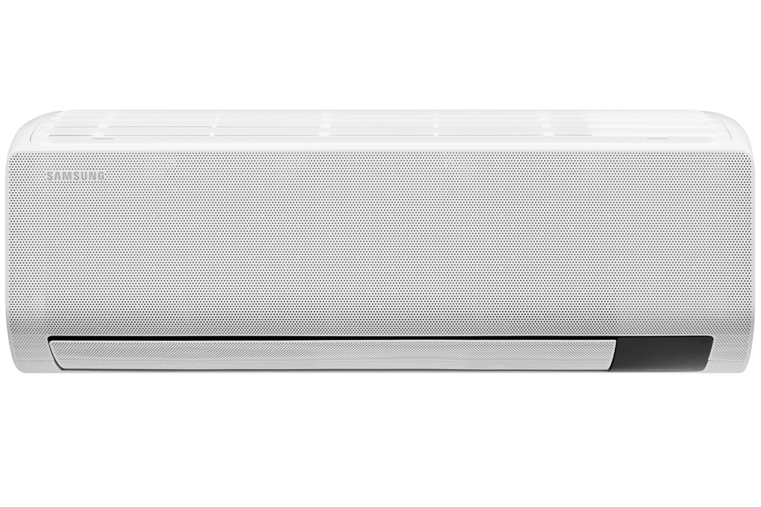

**PRICE IS TOO CHEAP**

**11,390,000 VND**

(-8%)No copper pipes and supplies will be given away.Delivery only, no installation.

**Technical specifications Samsung Wind-Free Inverter 1 HP AR10TYGCDWKNSV air conditioner**

* Machine Type:

1 way (cooling only) With Inverter

* Cooling capacity:

1 HP - 9,400 BTU

* Effective cooling range:

Under 15m² (from 30 to 45m³)

* Dust filter, antibacterial, deodorant:

Easy Filter Prefilter Tri Care Filter filters dust, anti-mold, antibacterial

* Power saving technology:

Digital Inverter BoostEco

* Rapid cooling:

Have

* Utilities:

Triple Protector Plus provides optimal protection for durable performance Fan Only mode - cooling only, no refrigeration Wind-Free mode for comfortable cooling Dehumidification function Self-cleaning function Mode sleep at night to avoid frostbite Radiator covered with Durafin anti-corrosion coating Timer to turn the machine on and off Screen displays the temperature on the condenser unit Automatically restarts when there is power 4-way air swing helps the cold air spread evenly

* Power consumption:

0.91 kW/h 5 stars (Energy efficiency 4.65)

* Cooler:

Length 82 cm - Height 30.5 cm - Thickness 21.5 cm - Weight 8.6 kg

* Outdoor:

Length 73 cm - Height 47.5 cm - Thickness 27.7 cm - Weight 19.4 kg

Introducing the company 

- A brand from Korea, founded in 1938.  
- Samsung is a multi-industry corporation, with a high level of brand recognition on a global scale.  
- Samsung's products range from mobile devices, home appliances, electronics,...  
- With the strength of being the brand of a global corporation, the quality of products always reaches the highest level of perfection. , good warranty should be trusted by customers around the world.

[**WindFree™ technology**](https://www.dienmayxanh.com/kinh-nghiem-hay/wind-free-cong-nghe-lam-lanh-cua-tuong-lai-1068729)**cools quickly without worrying about cold wind blowing directly**

In addition to instant fast cooling effect,  [Samsung Wind-Free Inverter 1 HP AR10TYGCDWKNSV air conditioner](https://www.dienmayxanh.com/may-lanh/samsung-ar10tygcdwknsv)  also has the option of WindFree™ cooling mode without direct blowing of cold wind.

Accordingly, when you choose this mode, the room will immediately reach the ideal cool temperature or gently blow cold air thanks to the 23,000  **small holes**  on the front of the air conditioner, **limiting direct wind while still maintaining** Maintains  the user's **desired temperature .**

**Filters 99% of viruses, bacteria, fine dust and allergens with**[**Tri-Care filter**](https://www.dienmayxanh.com/kinh-nghiem-hay/ly-do-chon-mua-may-lanh-samsung-wind-free-hoan-hao-1157372#easy-filter)

Certified by international organizations ITEA and Intertek, the Tri-Care filter on [Samsung air conditioners](https://www.dienmayxanh.com/may-lanh-samsung) is capable of **filtering 99% of bacteria, viruses, ultra-fine dust and allergens** , thereby providing a The air is always fresh and perfect for your home.

**Save energy up to 77% with Digital Inverter Boost motor**

Samsung AR10TYGCDWKNSV air conditioner is equipped with a Digital Inverter Boost engine that helps the machine use electricity efficiently to operate at low frequency but still maintain stable cold temperatures and save up to 77% of electricity (when combined with technology **)**  . WindFree™ cooling).

In addition, the Neodymium magnet and Twin Tube Muffler of the engine will help the machine  **operate quietly, smoothly and last a long time with an engine warranty period of up to 10 years.**

**Easily clean the filter yourself with the Easy Filter**

Samsung air conditioners use a filter called Easy Filter Plus, this filter can be **easily removed to clean** , keep the air conditioner running effectively.

The thick mesh keeps the heat exchanger clean, while the anti-bacterial coating protects your family from dangerous airborne contaminants.

**Automatically cleans and effectively prevents mold with the Auto Clean feature**

After operation, the Auto Clean feature automatically dries the heat exchanger using a 3-step process, **removing residual moisture by blowing air for 10 to 30 minutes** , thereby preventing the build-up of bacteria. bacteria and odors inside the machine and  users will save a lot of time and effort to clean [the air conditioner](https://www.dienmayxanh.com/may-lanh) .

**Ultimate protection for lasting performance thanks to Triple Protector Plus technology**

Triple Protector Plus technology prevents **internal damage** due to voltage surges or current fluctuations without the need for a separate voltage stabilizer. Together with the anti-corrosion coating, it will effectively protect the condenser and engine room in all harsh weather conditions.

**DuraFin anti-corrosion technology optimally protects the heat exchanger**

DuraFin technology **enhances the performance of the** machine's heat exchanger thanks to its thicker and denser design and improved coating to help prevent corrosion.

The excellent capabilities of this technology have passed the corrosion test standard in acetic acid seawater environment (according to SWAAT standards) for more than 100 days.

**Environmentally friendly thanks to the use of R32 refrigerant**

Samsung air conditioners using R32 refrigerant will limit the negative impact on our ozone layer, thereby preventing global warming more effectively than conventional R22 or R410A refrigerants.

**Capacity 1 HP, suitable for room area under 15 m2**

The Samsung Wind-Free AR10TYGCDWKNSV has a capacity of 1 HP, equivalent to 9400 BTU and is a suitable choice for rooms with a small area under 15 m2.

Overall assessment, the Samsung Wind-Free Inverter 1 HP AR10TYGCDWKNSV air conditioner meets the cooling needs of rooms under 15 m2. The air conditioner is not only equipped with advanced WindFree technology but also has the ability to effectively save electricity with the Digital Inverter Boost motor, while also taking less time to disassemble and clean with the Auto Clean feature for users.